**GENERATIVE AI**

AI is a branch of computer science that deals with the creation of intelligence agents, which are systems that can reason, learn, and act autonomously.

Essentially, AI has to do with the theory and methods to build machines that think and act like humans.

**NOW WHAT IS MACHINE LEARNING?**

Machine learning is a subfield of AI, it is a system or program that trains a model from input data, and that trained model can make useful predictions from new and never-entered data.

TWO MOST COMMON CLASSES OF MACHINE LEARNING MODELS ARE :

**UNSUPERVISED ML MODELS**-> it comes with predictions made from past events. Unsupervised is all about discoveries and looking at raw data seeing if it naturally falls into groups.

**SUPERVISED ML MODELS->** The key diff is that we have labels i.e. a name, a type, or a number.

a series of steps for supervised learning:

1) models are tested first and how? they are inputted with inputs first.

2) the model outputs the prediction based on the inputs and then compares it with the training data.

3) If the predicted test data values and actual training data values are far apart, that's called an error.

4) the model tries to reduce this error until the predicted and actual values are closer together. This is a classical optimization problem.

**NOW THERE IS TWO TYPES OF MACHINE LEARNING MODELS OR DEEP LEARNING MODELS**

Deep learning models, or machine learning models in general, can be divided into two types,

***generative and discriminative.***



Take this example here.

The discriminative model learns the conditional probability distribution or the probability of y, our output, given x, our input, that this is a dog and classifies it as a dog and not a cat.

**While the GENERATIVE AI model** learns the joint probability distribution or the probability of x and y and predicts the conditional probability that this is a dog and can then generate a picture of a dog.

**So to summarize, generative models can generate new data instances while discriminative models discriminate between different kinds of data instances.**

**What is a generative AI ?**

|  |
| --- |
| To summarize at a high level, the traditional, classical supervised, and unsupervised learning process takes training code and label data to build a model.  **The gen AI process can take training code, label data, and unlabeled data of all data types and build a foundation model.**  The foundation model can then generate new content.   1. For example, text, code, images, audio, video, et cetera. |

**Here are the associated model types.**

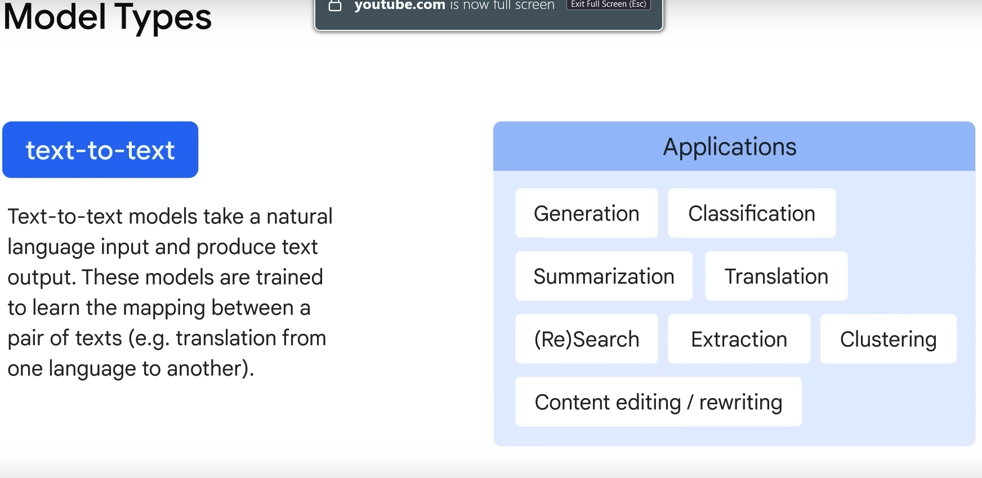

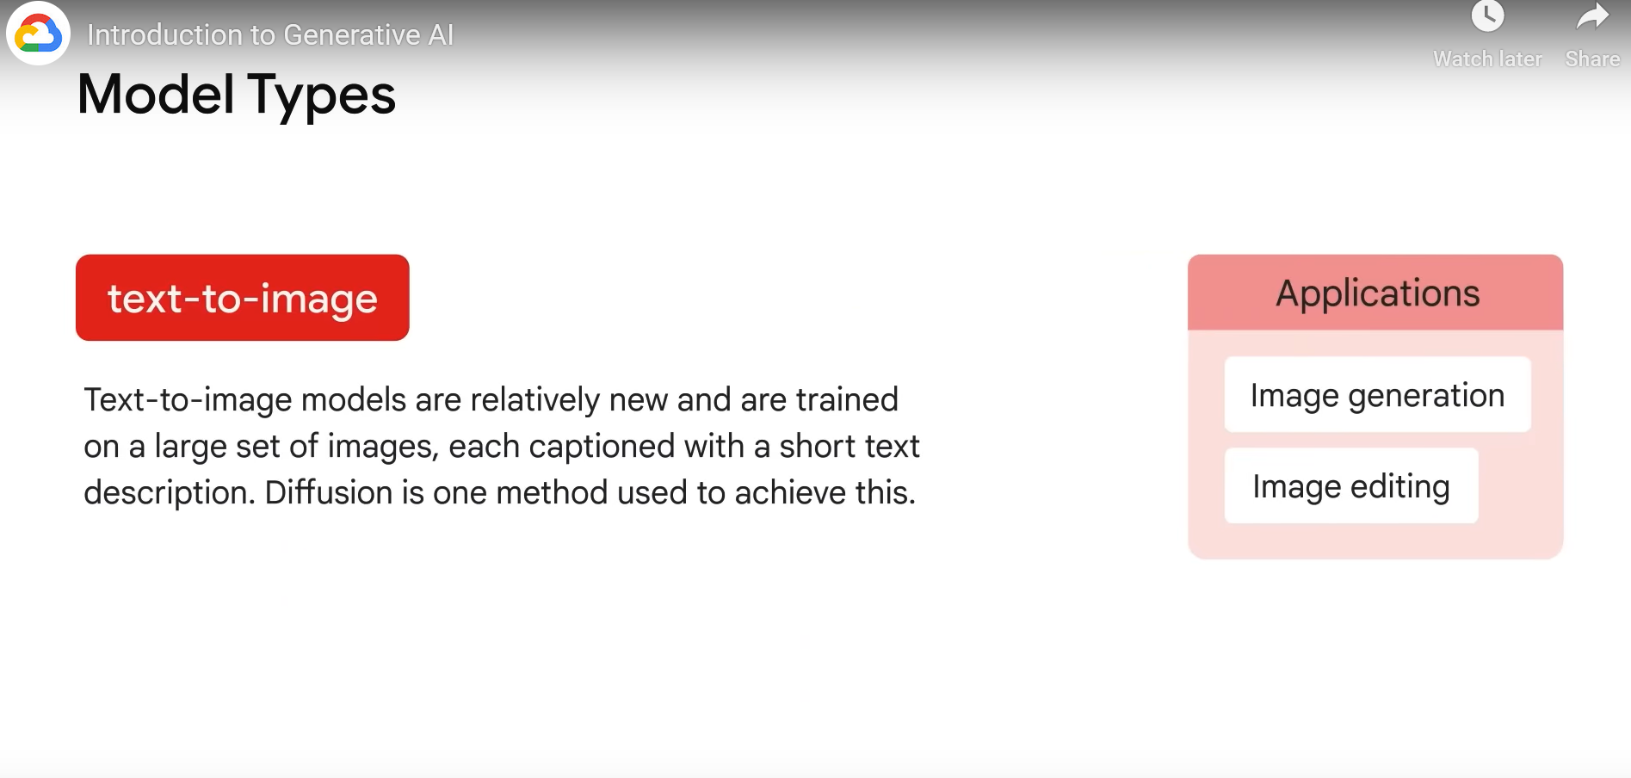

Diffusion is one method used to achieve this.

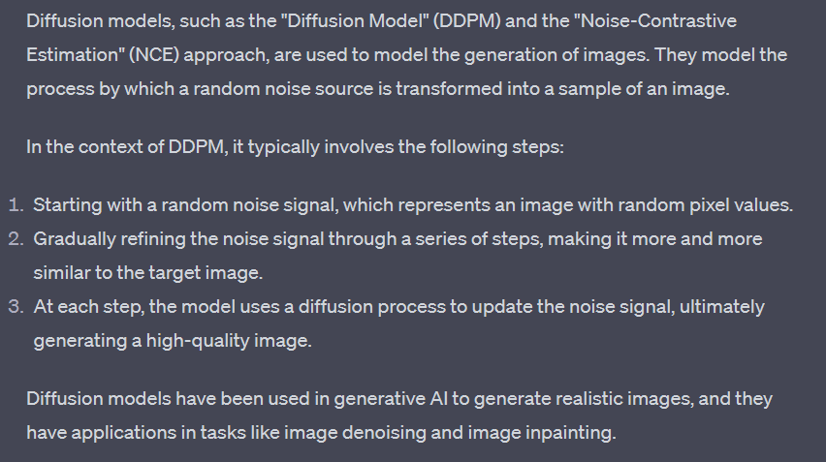

**For extra algorithms like Diffusion.**

**There are several algorithms from image generation to music composition through AI** 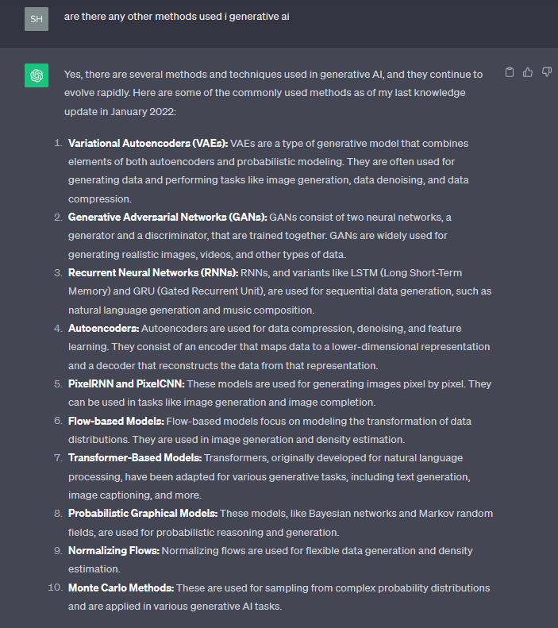

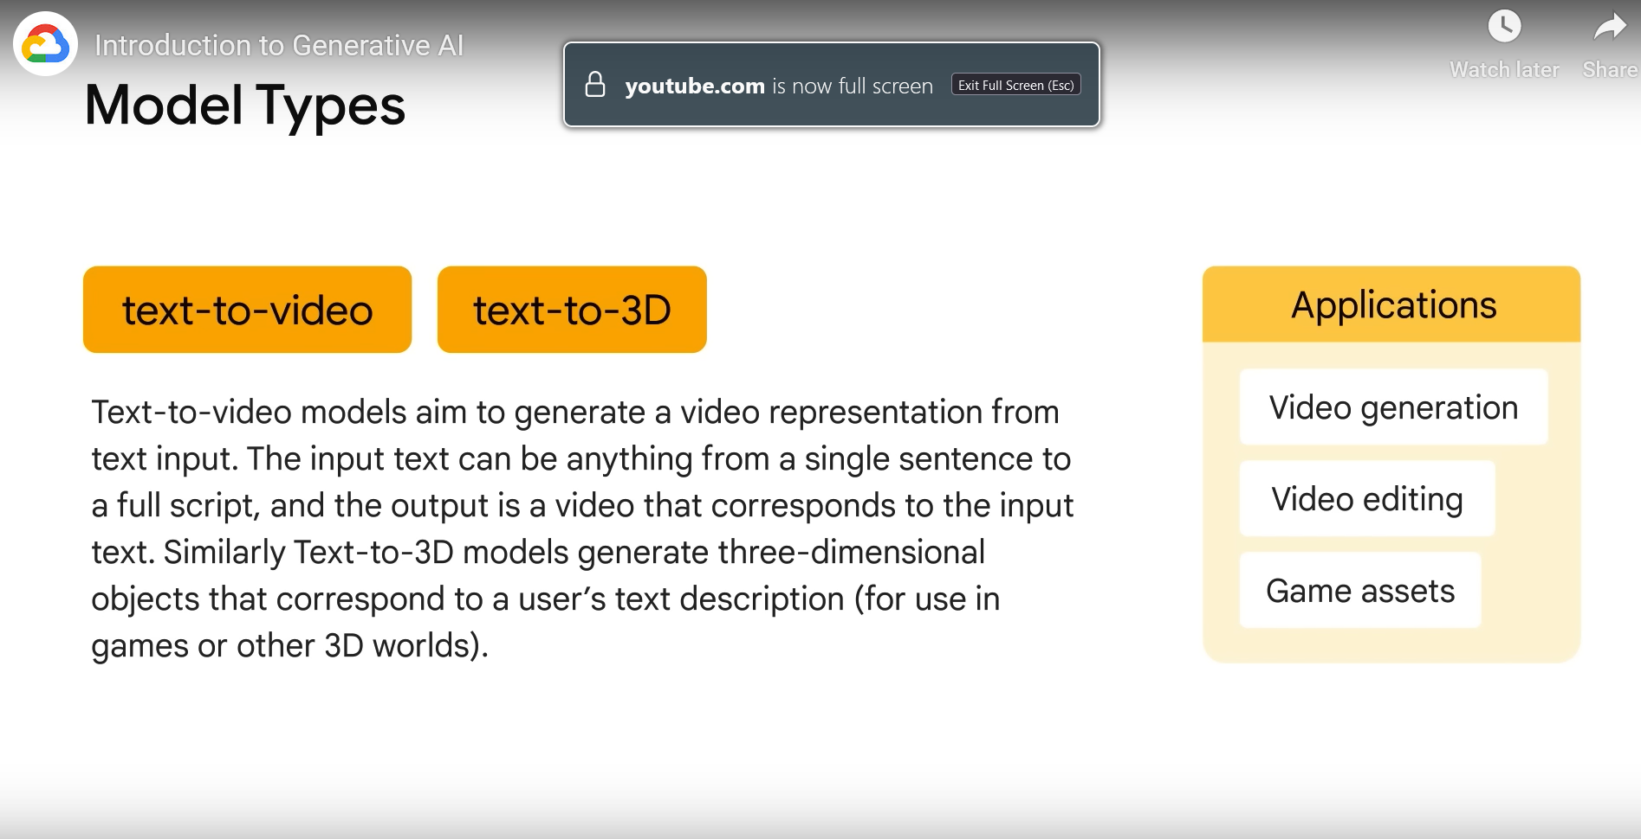

The input text can be anything from a single sentence to a full script.

And the output is a video that corresponds to the input text.

Similarly, text-to-3D models generate three dimensional objects that correspond to a user's text description.

For example, this can be used in games or other 3D worlds.

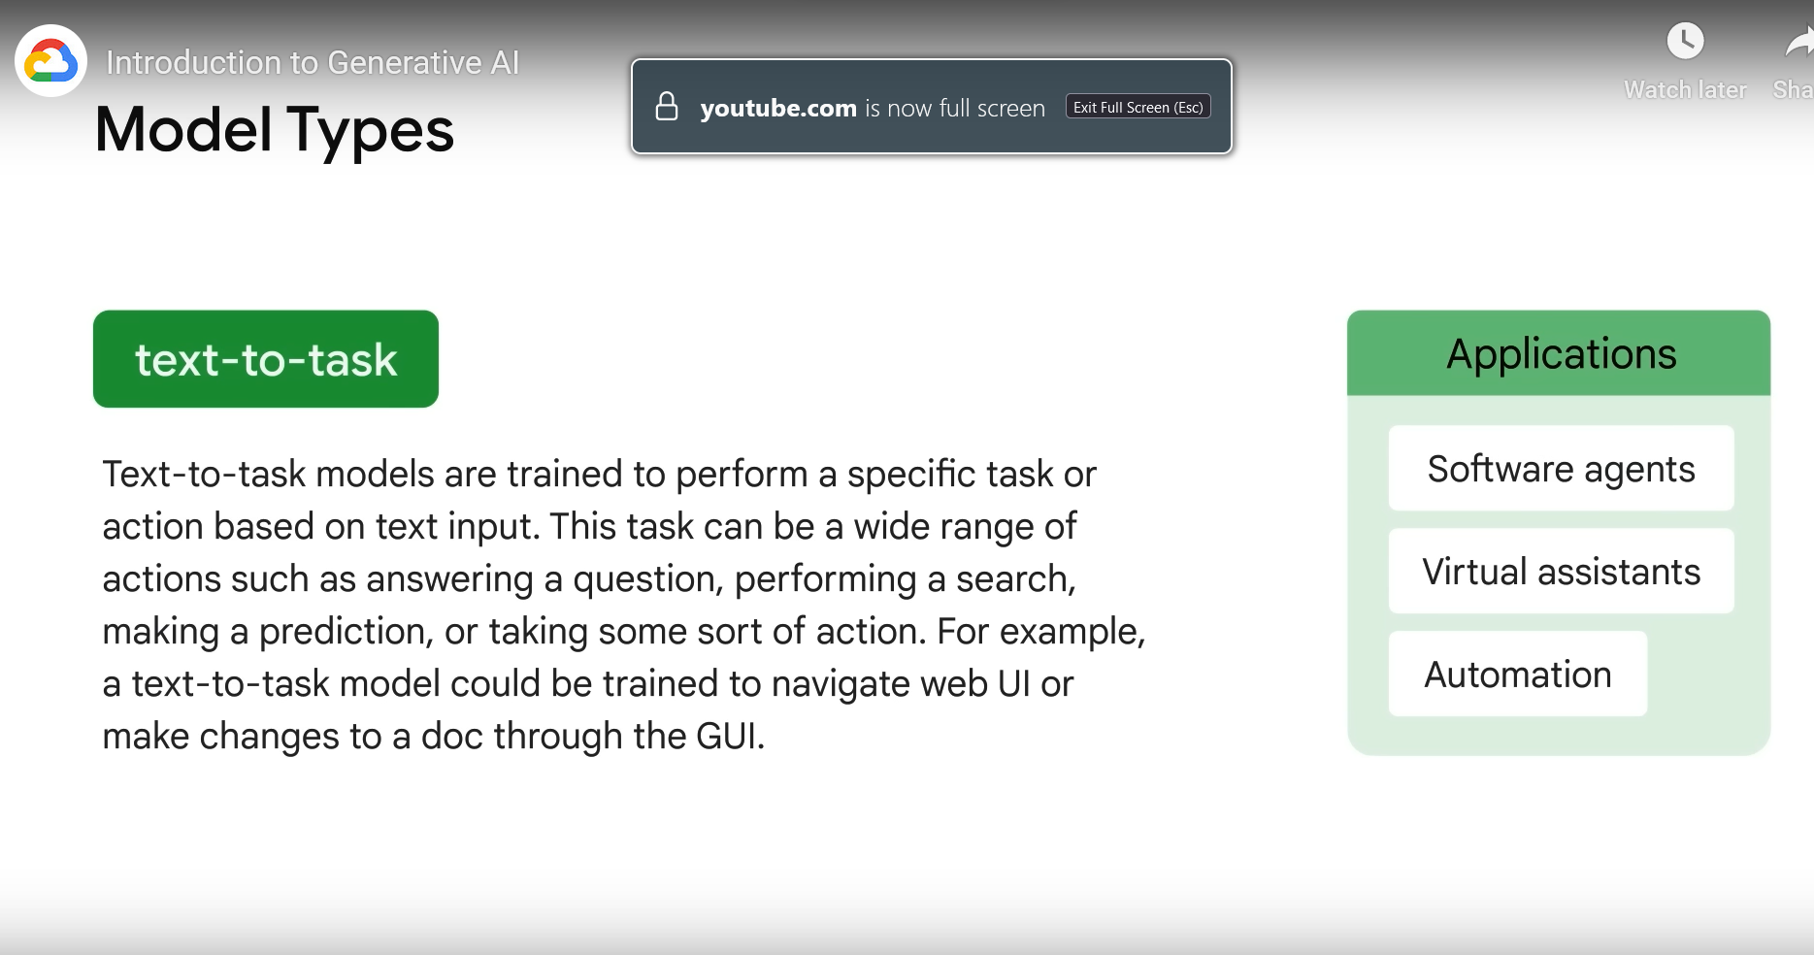

Text-to-task models are trained to perform a defined task or action based on text input.

This task can be a wide range of actions such as answering a question, performing a search, making a prediction, or taking some sort of action.

**The application of genAI.**

